**Project of web programming**

**Professor Armando Ruggeri**

**Parmida Azhir**

**Matricola:545480**

**Escape room website**

**List of topics**

* **Introduction**
* **Applying database**
* **Website design**

**Introduction:**

**This website is designed to help users to have access to every piece of information they may need and make this fun activity easier to manage. They can use this website in order to make reservations online, get to know which topic they want to choose and be in connection with the staff. Additionally, This website helps staff to manage the reservations and keep track of information needed from users. Languages used for this website are:**

* **HTML:** **To build the foundation of the website, structure of web page, and arranging elements like text, images, and links.**
* **CSS: To design the style of website such as selecting color, borders and positioning of content to create a user-friendly interface.**
* **PHP: To obtain and update information in the database, handle user interactions, and ensure smooth communication between the frontend and the database.**
* **JavaScript: To make the website more interactive.**

**Applying database:**

**In this project, I used Docker to host the database.**

* **Docker file:**

**Sets up the base image with PHP and apache. Run docker-php-ext-install mysqli: Installs the mysqli extension, which enables communication between PHP and the MySQL database.**

* **Docker compose:**

**Setup of three Docker containers providing a PHP environment, a MySQL database, and a phpMyAdmin interface for database management.**

**MYSQL part: Sets up a MYSQL database container for the project. It uses the latest MYSQL image and defines necessary environment variables to configure the database, including the database name, root password, and user credentials.**

**PHP part: Sets up a PHP container that serves the web application, ensuring it can interact with the MySQL database.**

**PhpMyAdmin part: Sets up a phpMyAdmin interface, which will connect to the MySQL database allowing users to manage the database through a web interface.**

* **Tables of database and what they show:**

1. **Admin table: Handles the credentials of administrators such as: id, email, etc.**
2. **Reservations table: shows the information about reservations of users.**
3. **Users table: Maintain information about each user. Such as: Name, email, passwords and etc.**
4. **User_login table: Monitor users login actions like: user_id, login time**

**Website design:**

* **Main page: The main page is designed for effortless navigation, showing sections such as *About, Scenarios*, *Register, and Login*. These sections provide users with quick access to essential information, helping them to explore the website and start their registration process effortlessly from the very beginning.**

**Also, the ‘make reservation if you DARE’ button is available so those who are familiar with the website and procedures. As a result, they can proceed from the very beginning without having to read the initial instructions.**

* 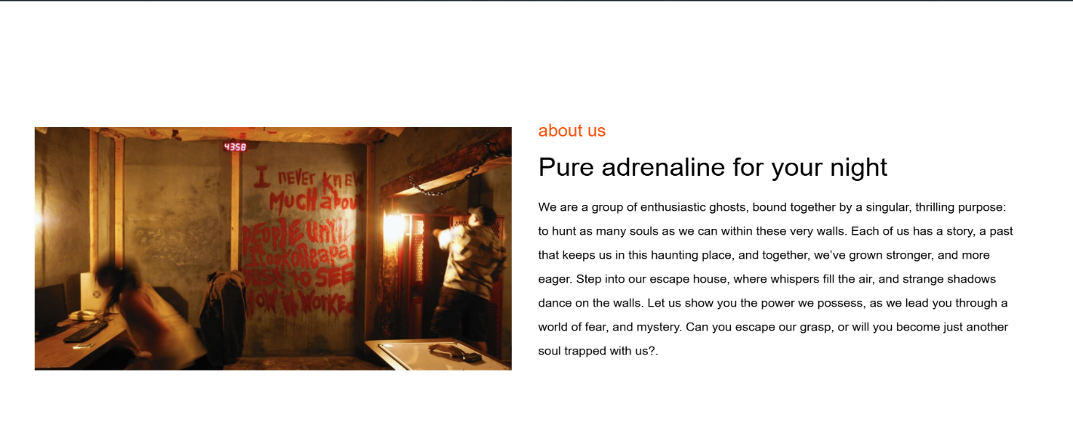**About us: The about us section gives a brief description of what is going to happen, and it keeps users engaged by arousing their curiosity. It gives enough detail to hint at what’s to come, without overwhelming users or leaving them uninformed.**
* **Our services: In this section participants can find the detailed version of services the escape room provides for their corresponding activity they have in their mind. They can emphasize the services they want in the Reservation section as a message so staff will take care of them.**

* **Process: The three main steps are explained to help participants get a clear understanding and ensure they know how to be prepared.**

* **A screenshot of a screen

  Description automatically generatedScenarios: In this section players can see the available scenarios and read each of them.**
* **Make reservations: Here users can fill in the form with their personal information following with the date and time they want to be at the escape room. In addition: they can specify the services they want during the games. From here they will be guided to the login section.**

**To elaborate on the steps: first, they must register an account, then log in to access their profile, and finally, proceed to make a reservation.**

* A screenshot of a computer screen

  Description automatically generated**Footer section: this part shows Location, contact details and opening hours.**

**As mentioned earlier: first, users must register an account, then log in to access their profile, and finally, proceed to make a reservation.**

* **Registration section: new users can sign up by entering their information like name, gender, and contact information. After submitting the form, the user's information is saved in the escape database in users table.**

* **Login section: In the login section users and the admin can gain access to their account via their email and password.**

**Upon successful authentication, they are directed to personalized dashboards according to their roles: an *admin dashboard* for managing system operations and a *user dashboard* for accessing user-specific features and services.**

**In the Escape database, the user_login table shows**

**user-id and their login time.**

* A screenshot of a computer

  Description automatically generated**User dashboard section: Here users will see the webpage, but they also have profile, booking and logout part.**
* **Profile section: Here users can access their data and manage their information. Not only can they update their main data. But also, they can change their password.**

* 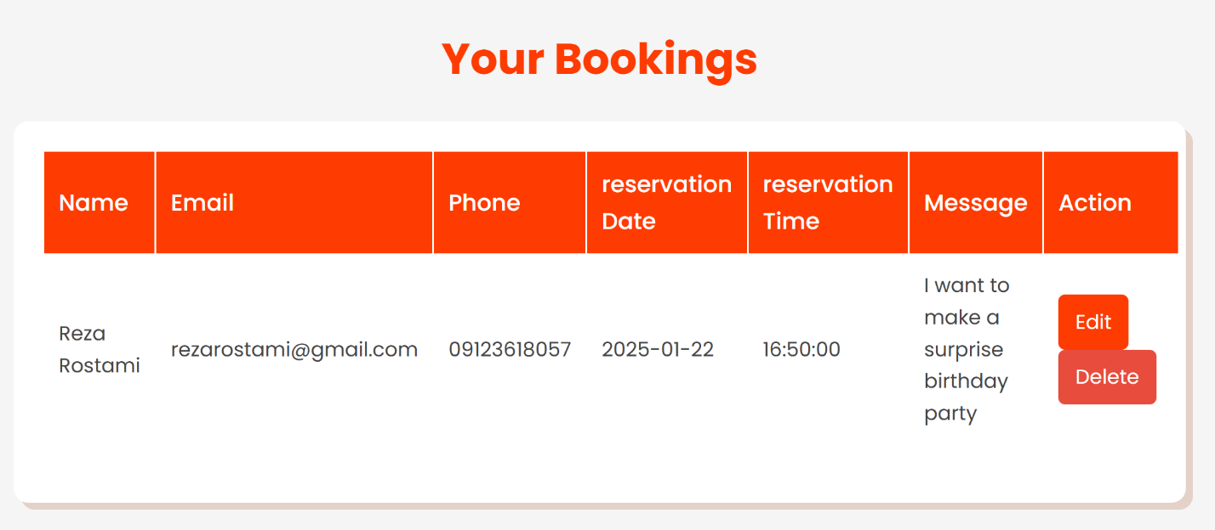**Bookings section: In this part users can see the details of their bookings. Also, they can delete or edit their previous bookings.**
* **This information is also displayed on the reservations table in the database.**

* **Admin dashboard: As an admin, they have the ability to view login details and manage user information and reservations, including editing or deleting records.**

* **My goal in designing this website was to create an engaging and interactive environment where users can not only enjoy their experience but also feel entertained. I aimed to make it enjoyable to navigate and easy to use. At the same time, I focused on making the platform user-friendly for admins, which allows them to manage tasks efficiently and comfortably, without unnecessary complexity. This approach ensures that both users and admins have a positive experience, whether they are interacting with the site or managing its content.**